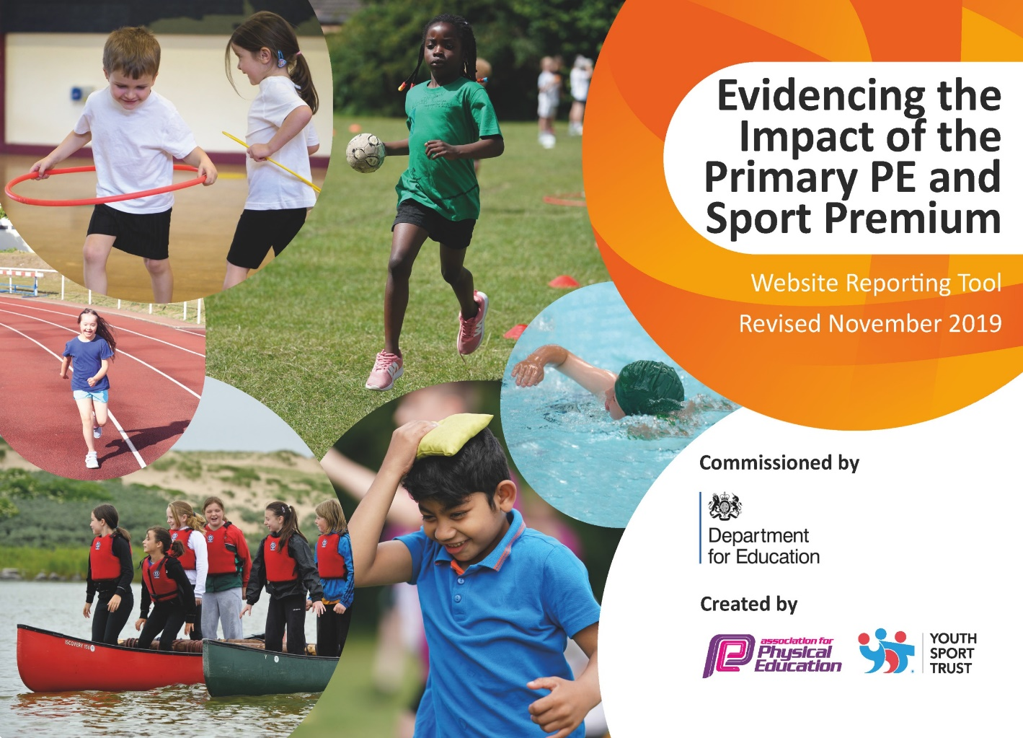



CRICH CARR

CHURCH OF ENGLAND

PRIMARY SCHOOL

SPORTS PREMIUM PLAN

2023-2024

**Evidencing the impact of Primary PE and Sport Premium 2022/23**

In 2023/24, we will receive a PE and Sport Premium allocation of £16,489. This document outlines how we have used the funding to make additional and sustainable improvements to the quality of PE and sport we offer. It outlines the 5 key indicators and how we have used the funding to help us to achieve these.

|  |  |
| --- | --- |
| Key achievements to date: | Areas for further improvement and baseline evidence of need: |
| * 100% of children year 6 are water confident and aware of water safety. * 100% of all children (Nursery – year 6) take part in inter-house school competitions. * 100% of KS2 children take part in inter-school competitions. * A wide variety of sports are available through school PE sessions and participation in School Sports Partnership including football, tag rugby, hockey, basketball, netball, tennis, table tennis, athletics, gymnastics, dance, swimming, water polo, outdoor adventurous activities, bikeability and balanceability. * Outdoor provision has been improved through installing a new all-weather surface and climbing equipment. * Lunch-time provision has been improved by timetabled daily sport activity supervised and run by a lunch time play leader. * All children have the opportunity to do Forest School sessions, accessing a weekly Forest Schools session. * Equipment has been purchased in order to introduce new non-contact sports / activities | * Further CPD is required for staff to continue to improve knowledge and skills. * Provide more competitive opportunities for the younger children (KS1 and lower juniors). * Increase the opportunities for active learning through improved provision, increased forest schools’ sessions and staffing to enable active and outdoor learning. * Improve assessment of PE to more effectively target teaching and build on existing skills |

|  |  |
| --- | --- |
| Meeting national curriculum requirements for swimming and water safety | Please complete all of the below: |
| What percentage of your Year 6 pupils could swim competently, confidently and proficiently over a distance of at least 25 metres when they left your primary school at the end of last academic year? | 100% |
| What percentage of your Year 6 pupils could use a range of strokes effectively [for example, front crawl, backstroke and breaststroke] when they left your primary school at the end of last academic year? | 100% |
| What percentage of your Year 6 pupils could perform safe self-rescue in different water-based situations when they left your primary school at the end of last academic year? | 100% |
| Schools can choose to use the Primary PE and Sport Premium to provide additional provision for swimming but this must be for activity **over and above** the national curriculum requirements. Have you used it in this way? | Yes |
|  | |

**Action Plan and Budget Tracking**

Capture your intended annual spend against the 5 key indicators. Clarify the success criteria and evidence of impact that you intend to measure to evaluate for students today and for the future.

|  |  |  |  |  |
| --- | --- | --- | --- | --- |
| **Academic Year:** 2023/24 | **Total fund allocated:**  £16,780.00 | **Date Updated: December 2023** | |  |
| **Key indicator 1:** The engagement of all pupils in regular physical activity – Chief Medical Officer guidelines recommend that primary school children undertake at least 30 minutes of physical activity a day in school | | | | Sustainability and suggested next steps: |
| School focus with clarity on intended **impact on pupils**: | Actions to achieve: | Funding allocated: | Evidence and impact: |  |
| * Introduce weekly Forest School sessions across the school. | * Additional staffing | £4250 | * 3Children have directed, staff led physical activity on at least 3 days per week for at least 30mins. | * Ensure that forest school is delivered effectively and is high-quality |
| * Increase opportunities for structured physical activity for all children. | * Timetabled lunch time play including supervised sports area – sports leaders and play leader to supervise this. | £2000 | * A high proportion of children do at least 1 hour of daily physical activity in school. | * Budget for continued provision * Ensure appropriate training is organized |
| * Additional support for swimming to improving swimming outcomes | * Smaller groups swimming * Less confident swimmers supported with staff member in the water | £1500 | * High proportion of children are water confident. * High proportion of children can swim 25m at the end of Y6 | * Continue to monitor impact on swimming attainment |
| * Improve EYFS children access to outdoor provision and increase amount of time they undertake physical activity in EYFS. | * Purchase new equipment and storage to facilitate physical activity. | £2800 | * Improved gross motor skills, fine motor skills, physical fitness, agility, balance and coordination. | * EYFS children to have at least two sessions of at least 30mins each day where they have access to outdoor provision. |

|  |  |  |  |  |
| --- | --- | --- | --- | --- |
| **Key indicator 2:** The profile of PE and sport being raised across the school as a tool for whole school improvement | | | | Sustainability and suggested next steps: |
| School focus with clarity on intended **impact on pupils**: | Actions to achieve: | Funding allocated: | Evidence and impact: |  |
| * Train sports leaders to support the delivery of structured physical activity at lunch times. | * SSP trainer to deliver programme and provide resource bank for sports leaders * Equipment to be purchased to support delivery | £1000 | * Higher take up of lunchtime and break time activities | * Repeat training as children move through school. |
| * Visit to provider of high quality PE (EIS / Loughborough University) so children can experience high quality facilities and see how top athletes train. | * Select venue * Book one-day activity programme exposing children to a wide range of sports | £1000 | * Inspired by experiencing a high-quality venue and by watching top athletes in action * Exposed to a wider range of sports | * Look at opportunities to increase exposure to new sports, venues and athletes |
| * Hire a sports hall to provide weekly indoor PE for all children. | * Confirm booking and schedule with Alfreton | £930 | * More appropriate environment for delivery of PE allowing for delivery of full curriculum | * Budget to continue this as school does not have an appropriate space for delivery of PE |

|  |  |  |  |  |
| --- | --- | --- | --- | --- |
| **Key indicator 3:** Increased confidence, knowledge and skills of all staff in teaching PE and sport | | | | Sustainability and suggested next steps: |
| School focus with clarity on intended  **impact on pupils**: | Actions to achieve: | Funding  allocated: | Evidence and impact: |  |
| * To provide support staff with mentoring and training to assist them with their increased role in sport. | * Mentoring and training provided by sports coordinator where necessary. * CPD through the sports partnerships undertaken. | £600  3 x release days | * Support staff more confident at carrying out their roles. * Sport provision improved through improved knowledge, skills and planning. | * Provide more training across a variety of sports. * Offer more CPD opportunities particularly focusing on new sport implementation and dance. * Sports coordinator to undertake more CPD to increase knowledge and update current knowledge. |

|  |  |  |  |  |
| --- | --- | --- | --- | --- |
| **Key indicator 4:** Broader experience of a range of sports and activities offered to all pupils | | | | Sustainability and suggested next steps: |
| School focus with clarity on intended  **impact on pupils:** | Actions to achieve: | Funding  allocated: | Evidence and impact: |  |
| * To take part in activities and competitions within the sports partnership. | * Pay into the Anthony Gell Sports partnership. * Pay into the Rural Derbyshire Sports partnership. | £1000 | * In a ‘normal’ year, 100% of children in the school have accessed opportunities through these partnerships. Resources were provided for online challenges and competitions, * Children have clear pathways available if they wish to pursue the sport further. | * Continue to provide the children with the range of opportunities offered through these partnerships. |
| * To link with sports clubs to provide clear pathways for the children. * Purchase equipment to support delivery of high-quality PE and active breaks | * Link with Matlock water polo club, Derwent Valley Orienteers, Swimming clubs and Martial Arts clubs. * Review existing sports equipment. Purchase following to support active: table-tennis equipment, cricket equipment, | £0  £1000 | * More children participating in a wider range of sports. * Wider range of sporting activities undertaken at lunchtime and break. | * Increase links with local sports clubs and invite them into school to lead sessions. |
| **Key indicator 5:** Increased participation in competitive sport | | | | Sustainability and suggested next steps: |
| School focus with clarity on intended  **impact on pupils**: | Actions to achieve: | Funding  allocated: | Evidence and impact: |  |
| * In-house competitions to take place. * To provide online opportunities to engage with others for challenges and competitions. | * Train sports leaders. PE leader to organize intra-school competition. * Pay into the Anthony Gell Sports partnership. * Pay into the Rural Derbyshire Sports partnership.   . | £1000  £1000 | * 100% of children have taken part in competitions. * Children have opportunities to compete against other schools. * This has maintained some links with our cluster schools. | * Continue to pay into the Anthony Gell Sports partnership and Rural Derbyshire Sports partnership. * Continue in person competitions between schools and inter house competitions within school. * Increase opportunities for KS1 and years 3 and 4 to enter competitions. * Organize activities but widen the range of sports offered. |